**HOW TO GRANT TRADING PARTNER ACCESS**

Belk has requested full unrestricted to their vendor’s catalogue this document will walk you through how to grant this.

To grant your trading partners access please follow the below steps –

1. Once you have logged into the GXS Active Catalogue go to Administration section on the main left hand menu bar and click Trading Partner access.

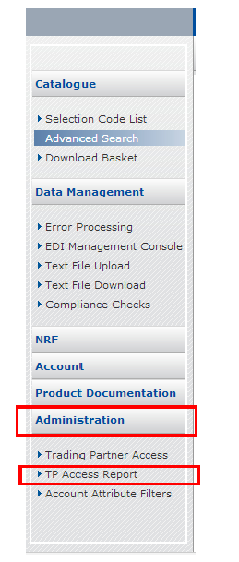

1. Type the Retailer name in the Trading Partner Name box and then click Filter.

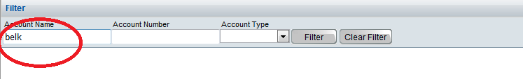

1. Your required Retailer will then appear under the Search bar, if you have not yet granted them access their Access Type will be displayed as Restricted.

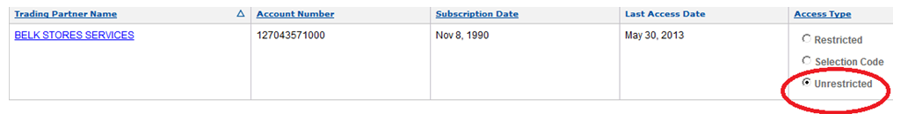

4. To grant your Retailer access to your full Catalogue you select Unrestricted and then click Apply.

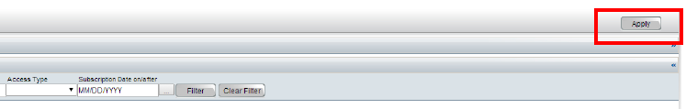

5. If you only want your retailer to see certain Selection Codes, then you need to select Selection Codes then click Apply.

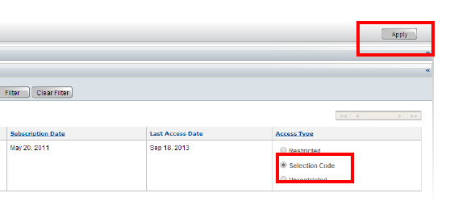

6. Once you have clicked on Apply a Selection Code List link will appear underneath the Access Types, click on the link to be taken to a list of your Selection Codes.

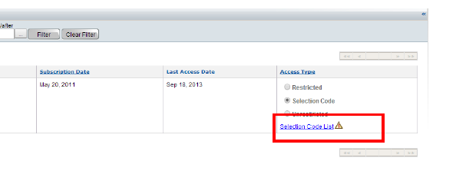

7. From the Selection Code List page find the required Selection Code/s for the Retailer and choose Unrestricted then click Apply.



8. If you want to grant access at Product level, then choose Product and Apply, once you click Apply a Product List link will be displayed for you to drill down to the product level to grant access at that level.

