GXS Active Catalogue
Creating a Prepack Relationship

In order to establish a Prepack relationship between UPCs (GTINs) within the GXS Active Catalogue, the Vendor must first upload the ‘Container’ (sometimes called the Parent) GTIN as well as the ‘Component’ (sometimes called the Child) GTINs which make up the Prepack relationship.

Below is a screenshot taken from the ‘GTIN List’ screen for an example Product/Style. You can see that 6 UPCs have been added. c highlighted in the screenshot below.

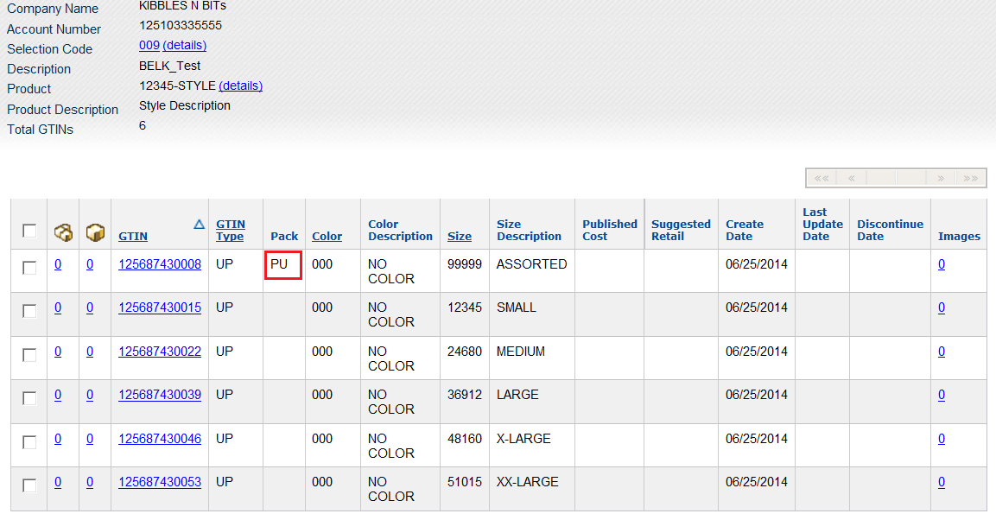
When adding any GTIN to the Catalogue, you will see an option to select a ‘Prepack/Container Code’ from a list (screenshot below). A valid Prepack code must be selected in order to create a Container GTIN.
*Selecting a Prepack/Container Code is only required for the Container/Parent GTIN and this field should be left blank for all Component/Child UPCs.
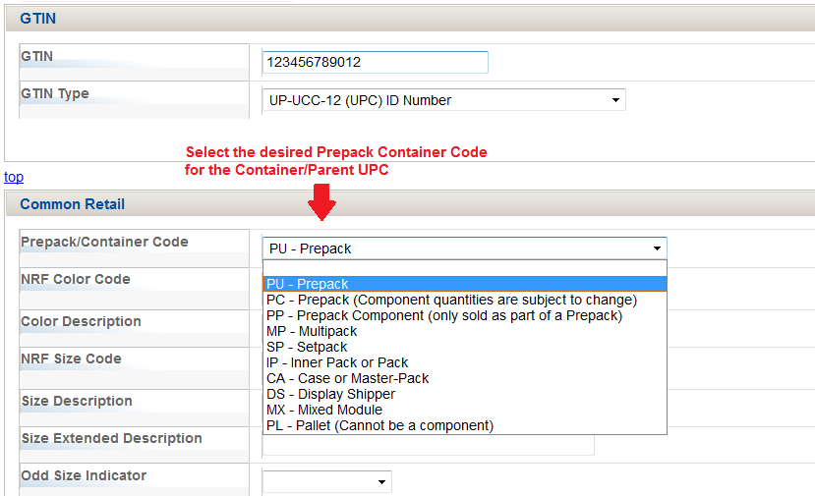

Note in the screenshot below that only the ‘Container’ UPC has been identified with a Prepack Code.
*Another thing to note about the Container/Parent UPC is that they can only be assigned NRF Size codes from 90000 and above. The Catalogue will generate an error if the Vendor attempts to assign an NRF code less than 90000.

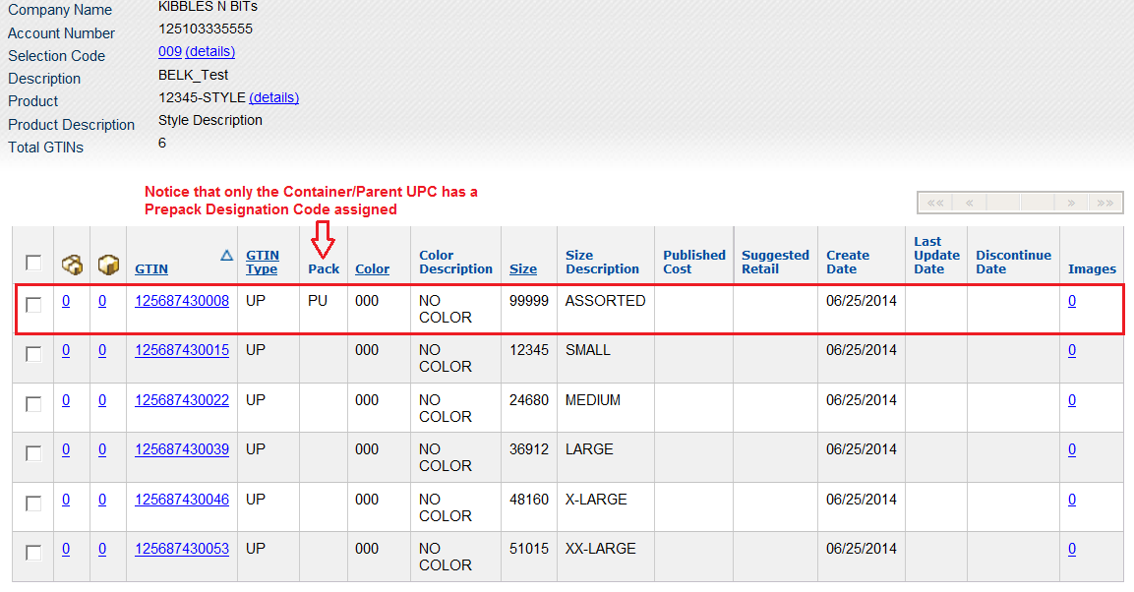

Once both the Container UPC and the Component UPCs have been added to the Catalogue, the Vendor must then create the Prepack relationship.
*this step is commonly missed by Vendors who are setting up Prepacks for the first time.
The 2 left most columns on the ‘GTIN List’ screen (indicated below) are the ‘Components’ and ‘Containers’ columns and serves 2 purposes:
1) Allows the client to create a Prepack relationship between 2 or more UPCs.
2) Provides an indication of the number of Containers/Component UPCs that have already been designated.
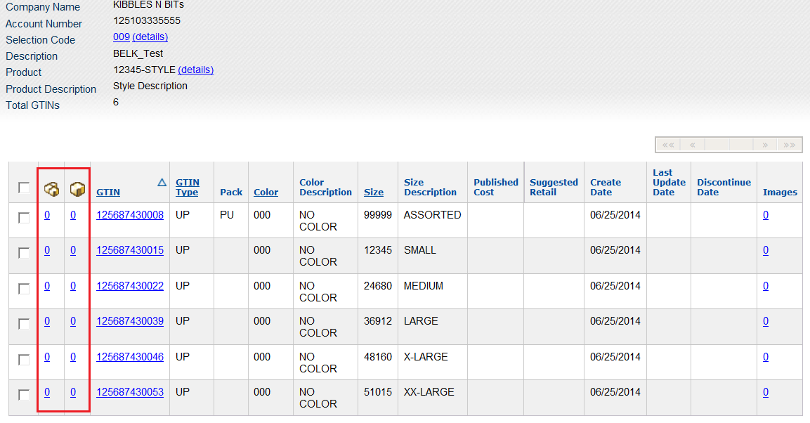

After adding the UPCs to the Catalogue, the first step is to locate the ‘Container’ (parent) UPC and click the number shown under the ‘Components’ column (indicated in screenshot below).
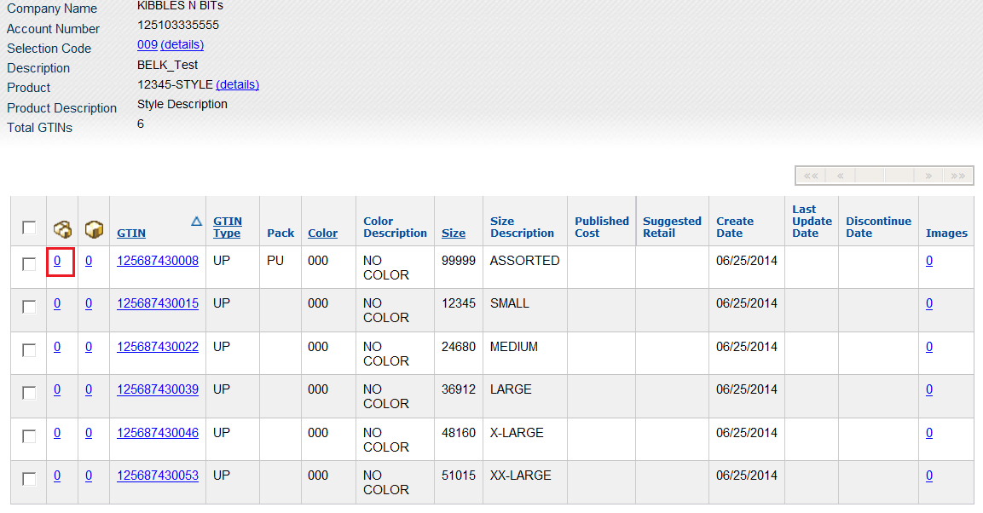

This will open the ‘View Components’ window shown below.
The Vendor should then click the ‘Add Component’ button indicated below.
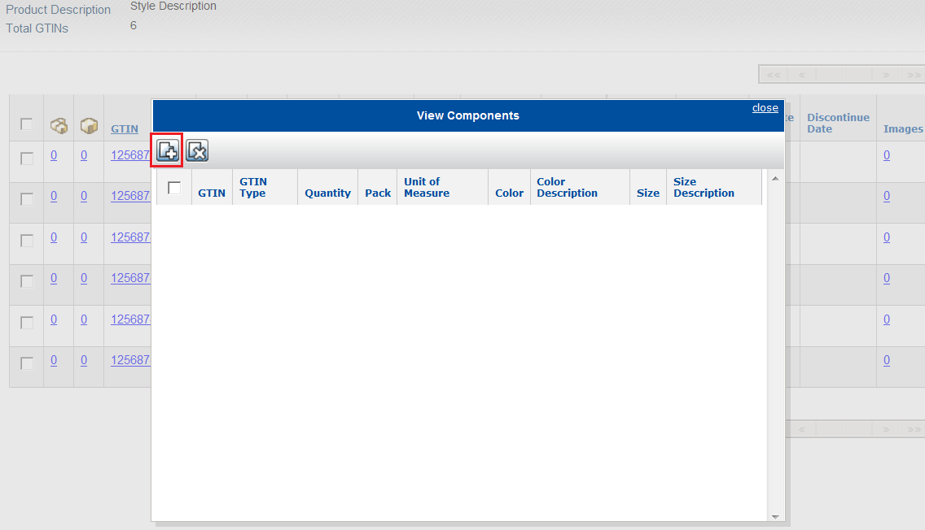

Upon clicking ‘Add Component’, the vendor is presented with the additional fields indicated in the screenshot below which they can use to identify the Component (child) GTIN number, the GTIN Type, and the Quantity.

The Vendor would then click ‘Save’ and the item will be added to the list of Component GTINs. The vendor will repeat this process until all component GTINs have been added.
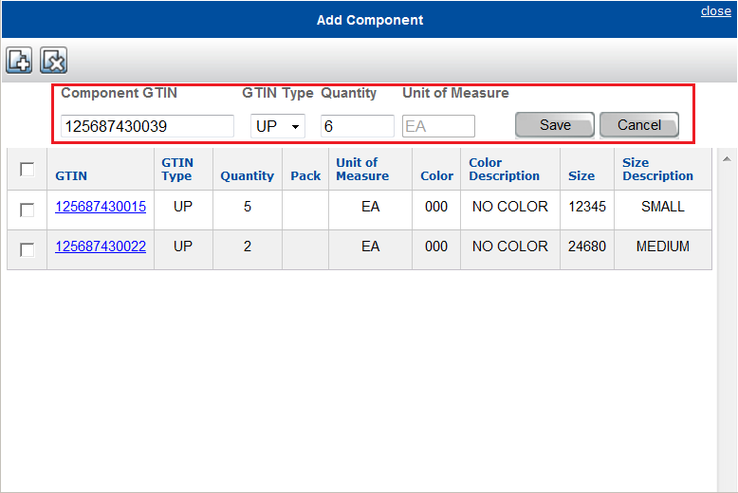

After all of the ‘Component’ GTINs have been added, the vendor can click ‘close’ in the upper right-hand corner of the window to complete the process.
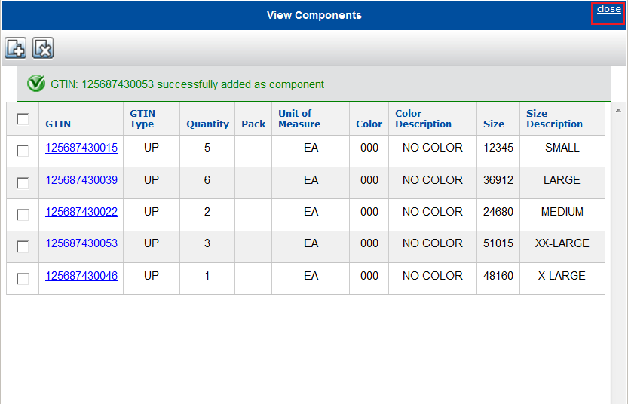

In the screenshot below you can now see that each GTIN has a Qty under the ‘Components’ column (in the case of the Container/Parent GTIN) OR under the ‘Container’ column (in the case of the Component/Child GTIN).
This allows the vendor to tell, at a glance, how many Component or Container GTINs have been associated with that particular GTIN.
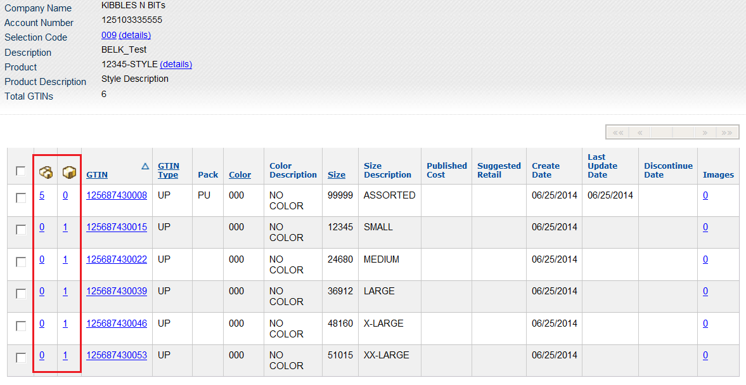
*It is possible for ‘Component’ GTINs to be associated with more than one ‘Container’ GTINs within the Catalogue.

