HOW TO GRANT TRADING PARTNER ACCESS

To grant your trading partners access please follow the below steps -
- Once you have logged into the GXS Active Catalogue go to Administration section on the main left hand menu bar andclick Trading Partner access.
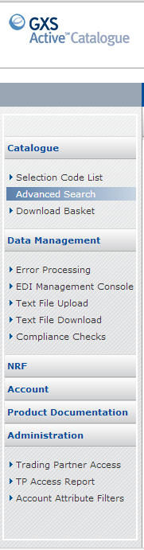

- Type the Retailer name in the Trading Partner Name box and then click Filter.
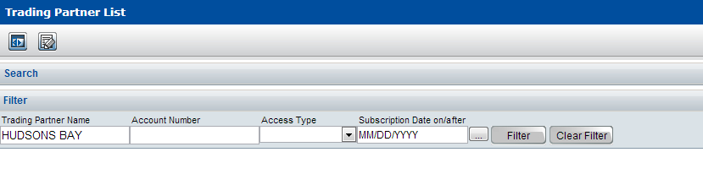
- Your required Retailer will then appear under the Search bar, if you have not yet granted them access their Access Type will be displayed as Restricted.
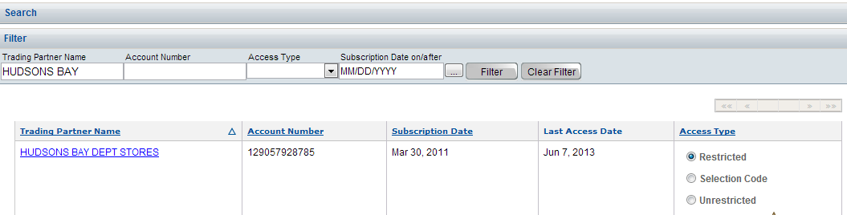

- To grant your Retailer access to your full Catlogue you select Unrestricted and then click Apply.
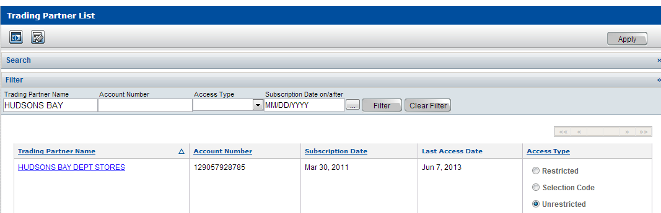

- If you only want your retailer to see certain Selection Codes, then you need to select Selection Codes then click Apply.

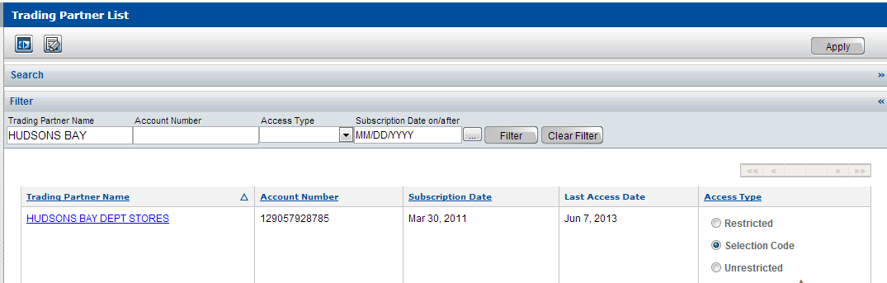

- Once you have clicked on Apply a Selection Code List link will appear underneather the Access Types, click on the link to be taken to a list of your Selection Codes.
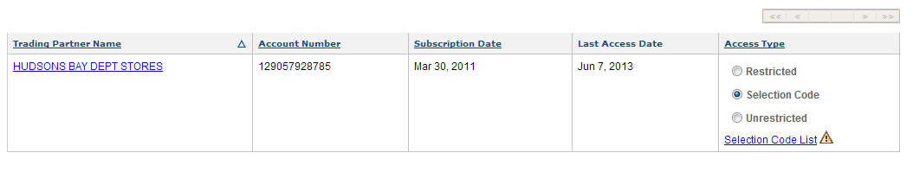
- From the Selection Code List page find the required Selection Code/s for the Retailer and choose Unrestricted then click Apply.
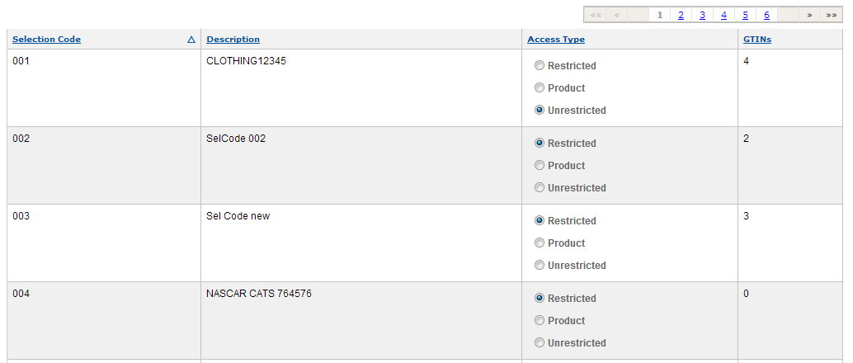
- If you want to grant access at Product level, then choose Product and Apply, once you click Apply a Product List link will be displayed for you to drill down to the product level to grant access at that level.
