Parking
In the immediate surroundings of Beurs van Berlage, there are a large number of carparks. Good priced parking near the event venue is ‘Parking Centrum Oosterdok’ (9 minutes walking distance and below Double Tree Hotel).
- Address: Oosterdokstraat 150, 1011 DK Amsterdam
- Prices: first 5 hours € 1,00 per 12 minutes. After 5 hours until 24 hours: € 20,00
- Amount of space: 1,700 parking spaces
- Maximum height: 2,10 meter
- Opening times: 24 hours, 7 days a week

When you enter the parking, drive to the back and take the last exit that says: ‘Uitgang Centrum’.

Directions towards the parking
By car, the Parking Oosterdok is easily accessible from the A10 ring road via the S114 exit. At the end of the S114 turn right on the S100/Piet Heinkade. Then turn right again after 2 kilometers on ‘De Ruijterkade’. Then turn right again after 400 meters on the ‘Oosterdoksstraat’. You can see the entrance of the parking on your left hand.

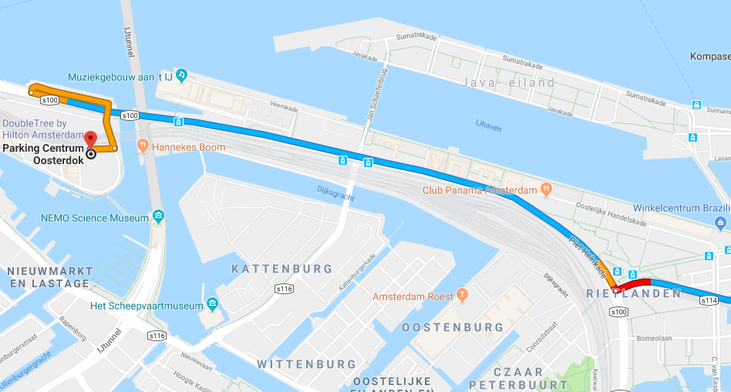
Directions (car) towards parking

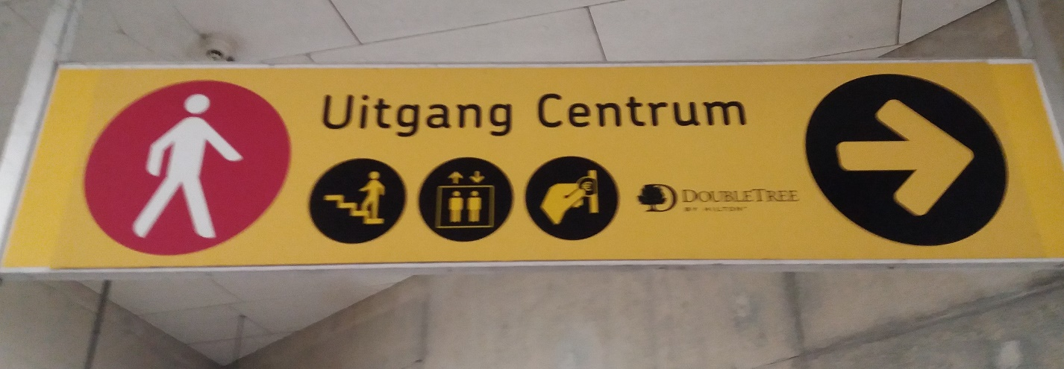
Exit sign in the parking

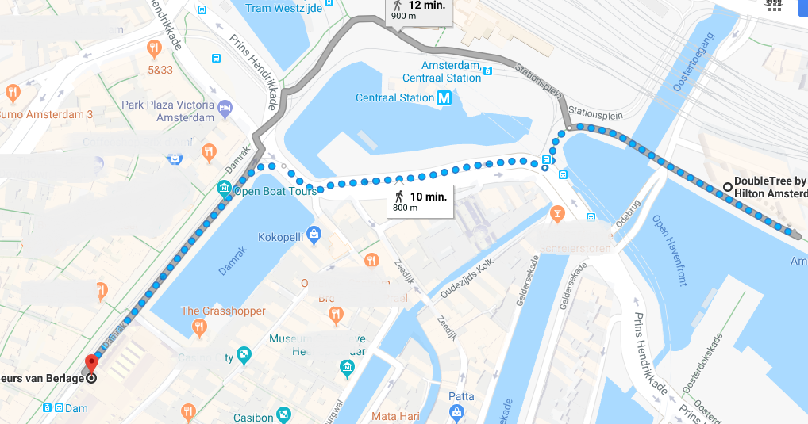
Directions (walking) towards Beurs van Berlage from Oosterdok parking

